Traditional Chinese Medicine  - Internal treatments  - Nutritional Diet therapies, Chinese Herbal Medicine  - External treatments:  - Acupuncture, Moxibustion, Cupping & Tui Na | - Acupuncture utilizes needles to stimulate, regulate and influence Qi and Blood of the body through acupuncture points to treat disease and promote physical and mental health  - Earliest acupuncture instruments  - Bian stone, Stone needle  - Bone, bamboo & pottery needles  - Originated during Color Pottery Culture in Yellow River Area

Nine Ancient Needles | Length | Shape | Purpose | Treats
Filiform Needle**  [Hao Zhen] | Various Lengths | - Very thin  - Well-made, safe & comfortable for patient | - Model for modern needles  - Most common needle used clinically  - Pre-sterilized | Various Symptoms & Syndromes
Sharp Needle *  [Three Edged Needle]  [Feng Zhen] | 1.6 cun | - Body: Cylindrical  - Tip: Very sharp & shaped like an awl with 3 edges | - Venipuncture or bloodletting  - Prick points & collaterals to cause bleeding | - Carbuncles, excess  Excess Heat syndromes
Long Needle*  [Chang Zhen]  [Huan Tiao (GB 30)] | 7.0 cun | - Thin & strong | - Deep insertion into big muscle groups | - Bi Syndrome  - Pain deep in the body
Arrowhead Needle  [Chan Zhen] | 1.6 cun | Arrowhead  - Large head  - Very sharp tip  - Smaller part directly above end of tip is sharper tip | - Pierce skin superficially to cause bleeding | - Heat or excess syndromes
Round Needle  [Rounded Tip Needle]  [Yuan Zhen] | 1.6 cun | - Body: Cylinder  - Head: Rounded like an egg | - Massaging points  - Use gently to avoid muscle injury | - Qi stagnation in muscles or clefts between muscles
Pressure Needle  [Di Zhen] | 3.5 cun | - Tip: Like a grain of millet  - Round & only slightly sharp | - Shallowly press along channels | - Massaging tool
Sword Needle  [Pi Zhen] | Length: 4.0 cun  Width: 0.25 cun | Sword  - Two sharp edges | - Cut or lance abscesses | - Surgical instrument for external use only
Round Sharp Needle  [Yuan Li Zhen] | 1.6 cun | - Tip: Sharp  - Middle: Larger  - Body: Thin & round | - Rapid pricking | - Bi Syndromes  - Carbuncles
Large Needle  [Fire Needle]  [Da Zhen] | 4.0 cun | - Thick, round body | - Insertion into joints | - Remove pathogenic fluid by pricking points

Filiform Needle Parts |  | 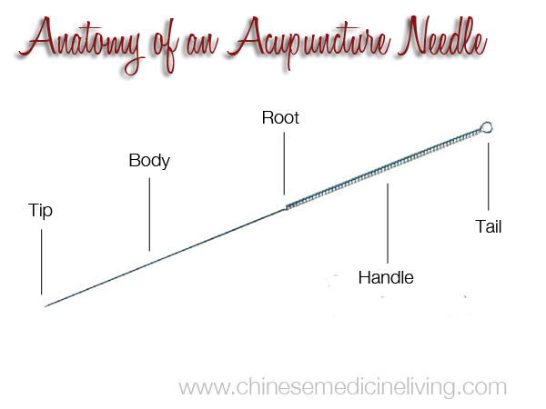
Tail | - End of handle  - Place loose moxa here for warming needle technique
Handle | - Part of needle held for insertion & manipulation  - Wound with metal filigree or plastic
Root | - Demarcation between Body & handle
Body | - Shaft of needle between handle & tip  - Should be smooth & straight
Tip | - Sharp point of needle  - Leads needle into acupuncture point

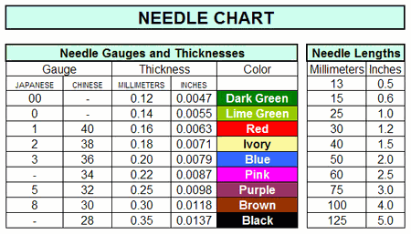

Gua Sha  - Definition  - Gua = scraping/rubbing  - Sha = “sandy diseases”  - Refers to different things:  - Acute illnesses [sunstroke, gastritis, cholera, convulsions, etc.]  - Petechiae or reddish, elevated millet-like skin rash  - Unknown virus or bacteria inhaled or enters through skin  - Functions  - Opens orifices  - Detoxes Heat & fire poison  - Clears exterior condition  - Balance Yin & Yang  - Manipulation  - Use porcelain spoon or Gua Sha tool with oil  - Scrape along DU, UB, ST meridians, elbow, shoulder, wrist, popliteal fossa until skin gets red or dark red  - Directions  - Chest: Medial Lateral  - Posterior aspect of body: Superior Inferior [start at base of neck]  - Abdomen: Superior Inferior  - Limbs: Proximal Distal  - Color: Petechiae should fade within 2-4 days. If it takes longer to fade, can indicate poor blood circulation  - Very Light: Blood Deficiency  - Fresh Red: Recent penetration of Sha  - Dark Red: Heat  - Purple/Black: Long term blood stasis  - Indications: Acute Excess Diseases  - Wind Cold: GB 20, UB 11, LU 1  - Wind Heat: Along UB meridian  - Acute gastroenteritis: REN 4 & 6, ST 25, ST 34, ST 36, ST 37, SP 9  - Headache: GB 20, GB 40, ST 8, Tai Yang, LI 4, LU 7  - Sunstroke: DU 26, LI 11, PC 3, PC 8, KD 1  - Acute Sore throat: Along DU channel on upper back, LU channel from elbow to thumb  - Chronic Sore Throat: REN channel on upper chest  - Cough & Phlegm: Upper chest, Upper back along DU channel  - Precautions/Contraindications  - Do not apply to broken or ulcerated skin, lumps  - Abdominal & sacral regions of a pregnant woman  - Caution: Patients susceptible to spontaneous bleeding, low platelet counts, too weak or too nervous  Different needling reactions [De Qi]  - Distention & soreness: Indicates good outcome. Often seen with deficiency syndromes or constitutions.  - Heaviness: Feeling of not being able to move a part of body because it feels heavy. Common with LI 4.  - Tingling: Up/down channel or at point. Good indication that channel stagnation has been shifted or moved.  - Numbness/Electric Shock Feeling: Stronger reaction. Can be helpful in excess syndromes, acute pathologies & patients with strong constitutions. If patient reports a point or larger area feels numb, can have several causes Reassure patient & do Tui Na after removing needles. Possible causes: Needling too strongly, Needling into nerve tissue, Underlying blood deficiency  - Heat Sensation: Desirable response when patient suffers from cold syndrome (cold, deficiency, arthritis, diarrhea due to cold-damp, low back pain due to kidney deficiency, facial paralysis, muscle atrophy)  - Cold Sensation: Positive response in treatment of heat syndromes (Wind Heat invasion, dysmenorrhea or migraines due to Liver Fire or Blood Heat, Stomach Fire, etc.)  - Sharp pain not intended or acceptable for vast majority of points, except Jing Well points and some others in thin-skinned, thin muscled areas on hands, feet & ear. | Insertion angles:  - Perpendicular: 90 degrees  - Most common angle for insertion  - Used where muscles are thick/dense & no danger of internal organ damage.  - Oblique: 45 degrees  - Used where subcutaneous flesh is thin or internal organ lies beneath point.  - Commonly used on chest & back.  - Transverse or horizontal: 10-25 degrees  - Used in areas of little flesh or very thin muscles. Used for points on head, face & some chest points.  - Also an appropriate angle for running needling to join points or for threading techniques.  Needle Insertion Techniques  - Freehand Insertion  - Help of a pressing finger  - Stretching the Skin  - Pinching the Skin  - Two Hands  - Basic Withdrawal Technique  - Fast, Slow  Fundamental Manipulation Techniques  - Thrusting & Lifting: Excess Syndrome, Strong Constitution  - Twirling or Rotation: Stimulates Qi response  - Strong: Large arc (360 degrees), Rapid frequency  - Mild: Lesser arc (180 degrees), Slower frequency  - Do not rotate needle in just one direction in a large arc because it can damage tissue or lead to stuck needle  - Tube Insertion Methods  - Squeezing, Nail Flicking, One Tap, Two Taps, Flutter  Six Auxiliary Manipulation Techniques  - Pressing: Along meridian to  - Increase Qi sensation  - Plucking: Flick needle to cause trembling  - Increases Qi sensation  - Strengthens stimulation to obtain Qi  - Deficiency: In direction of channel  - Reinforcement: Pluck handle after arrival of Qi, insert needle deeper  - Scraping: Scrape needle handle  - Spread needle sensation & vibrations Move the Qi  - Shaking: Move needle back & forth with fingers on needle handle  - Increase Qi sensation  - Draining: Shake & lift out  - Flying: Twirl needle quickly 3 times until sensation strengthened  - Increase Qi Sensation  - Rotate a few times, then fly open  - Trembling: Different than lift & thrust, creates vibration  - Increases Qi sensation  - Moves the Qi

